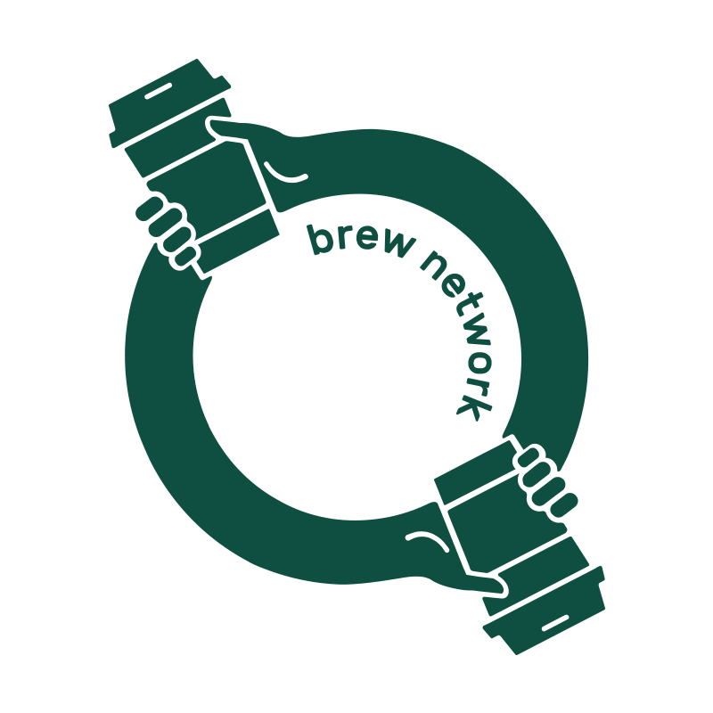

**Press Release**

Embargoed for: Monday December 7th 2020

**Brew Network App launched to support local cafes, bars and restaurants.**Shout your contacts a coffee, beer or wine from Perth Partner Venues.

An app designed to support local hospitality businesses post COVID-19 and shout your contacts a beverage from the palm of your hands has officially been launched.

The Brew Network is an app that provides a platform for users to send a coffee, beer or wine to their friends, family or colleagues from their smartphone device.

The way it works is simple.

Once you have downloaded the app, select the type of brew you would like to send, then select the recipient from your contacts and write a personalised message.

Shortly after, your contact will receive a text message for their ‘free’ beverage with a link to download the app to claim their brew.

Developed by a team of passionate coffee drinkers, Brew Network is a sister company to Cleaver Street & Co. in West Perth.

Leading the team is Cleaver Street & Co owner, Cade Eglington.

“The concept behind Brew Network came about over several years operating The Cleaver Street Coffee Shop,” Mr Eglington said.

“The app was in ideas stage for a couple of years, but after our own business went on hiatus due to COVID, we decided to develop Brew Network and provide an easy way for communities to get behind their local hospitality venues.”

The app was designed and developed by members of the Cleaver Street Coworking Studio this year.

“All of us know someone that needs cheering up, or have a friend we haven’t seen in a while and this app is a great way to stay connected and show you care,” Mr Eglington said.

The free app can be downloaded from [**https://brewnetwork.com.au/DL**](https://brewnetwork.com.au/DL)**.**

Brew Network beverages can be redeemed at:

Village Coffee (Marmion)Rise & Grind Espresso (Doubleview) Dimattina (Osborne Park)Stomp Coffee (North Perth)Little Lion Coffee (Perth Children’s Hospital)

Shadow Wine Bar (Northbridge) The Seasonal Brewing Co. (Maylands) Laika Coffee (Lathlain)

Good Things (Mosman Park)

*MUMMUCC' (Wembley)

*Nowhereman Brewing Co. (West Leederville)

*Coming soon. Account activation in progress.

Cafes and bars can sign up to become a part of Brew Network at **https://brewnetwork.com.au/partner**

For more information visit our website:  
[**https://brewnetwork.com.au**](https://brewnetwork.com.au/)

**Quotes from some of the Brew Network Partner Venues:**  
  
*“With Brew Network we have an opportunity to bring communities together in such a unique time. Looking after friends and family and supporting local, what’s not to love!”*  **Kauri Minhinnick - Events and Marketing, Alex Hotel & Shadow Wine Bar**

*“Epic new way to look after the ones you love! Simple and effective, a value add with no fuss”* **Chris Watt - Owner, Stomp Coffee**